**OUTREACH TEMPERATURE CARD**

Name: Date:

My Current Temperature:

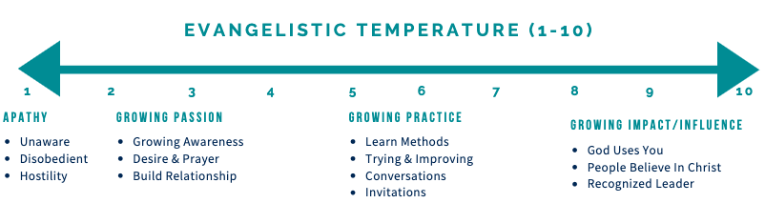

Recent Progress in Relationships or Spiritual Conversations:

|  |  |  |
| --- | --- | --- |
| Unchurched People in my life:   * **F**riends * **R**elatives * **A**cquaintances * **N**eighbors * **C**olleagues | BLESS practices I will pursue to help encourage them to take another step toward Jesus:   * **B**egin with Prayer: for and with unchurched people * **L**isten: ASK QUESTIONS, including about their spiritual story * **E**at: Show hospitality and build the relationship * **S**erve and Ask for Help: Care for them, let them care for me * **S**hare my Story and the Good News of Jesus: Invite Response | Date: |
|  |  |  |
|  |  |  |
|  |  |  |
|  |  |  |
|  |  |  |
|  |  |  |