Church Name: Date: Our Current Temperature:

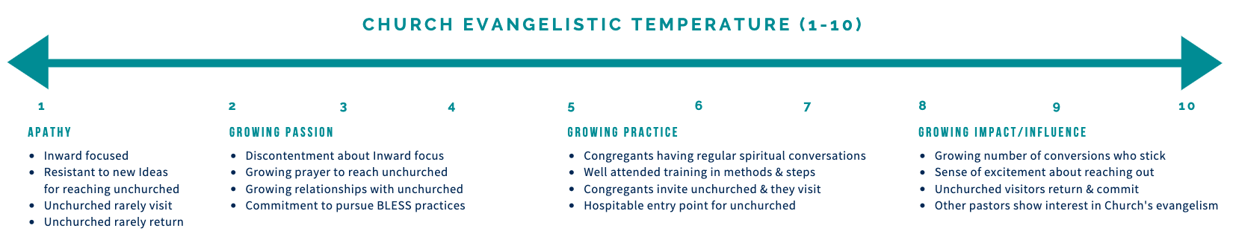

Recent Progress or Story of Outreach through events/leaders/groups/conversions:

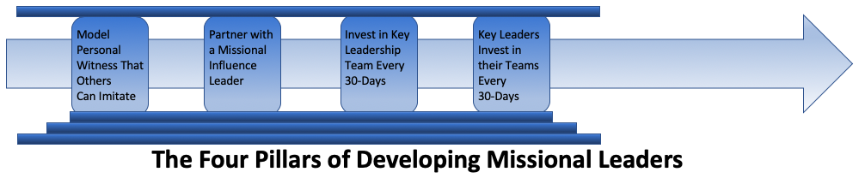

|  |  |  |  |  |  |
| --- | --- | --- | --- | --- | --- |
| **Pillar** | **One** | **Two** | **Three** | **Four** | **Comments:** |
| **Progress:** |  |  |  |  |  |
| **Next Steps:** |  |  |  |  |  |
| **Date:** |  |  |  |  |  |